CST8002 Programming Language Research Project
Evidence of Learning
Submitted By: Samatar Abdullahi,
Student ID: 041198705

Submitted to: Professor Stanley Pieda
in partial fulfillment of the requirements for CST 8002_302

Computer Programming
Algonquin College

Sep 25, 2026

CST8002 Programming Language Research Project
  - Practical Assessment 3 – Proof of Concept - See Brightspace for due date

Research
  - A resource that is a reference, like API Library documentation, for unit testing in your programming language of study.

Ressource: How to write Unittest in Web apps.

[1]
M. Grinberg, “How to Write Unit Tests in Python, Part 3: Web Applications,” blog.miguelgrinberg.com. https://blog.miguelgrinberg.com/post/how-to-write-unit-tests-in-python-part-3-web-applications (accessed Oct. 10, 2026).

  - A resource on best practices for unit testing, this can be specific to your programming language of study, or a general resource applicable to any programming language.

[2]
“Unit testing in Python: Quick tutorial and 4 best practices,” Octopus.com, 2026. https://octopus.com/devops/unit-testing/unit-testing-in-python/ (accessed Oct. 10, 2026).

  - A resource that is a tutorial for implementing a unit test, using a unit testing library, in your programming language of study.

[3]
Cody Engel, “How To Write Unit Tests (The Right Way).” YouTube, Feb. 22, 2021. Accessed: Oct. 10, 2026. [Video]. Available: https://www.youtube.com/watch?v=aId-WLZnvkw

Program Demonstration
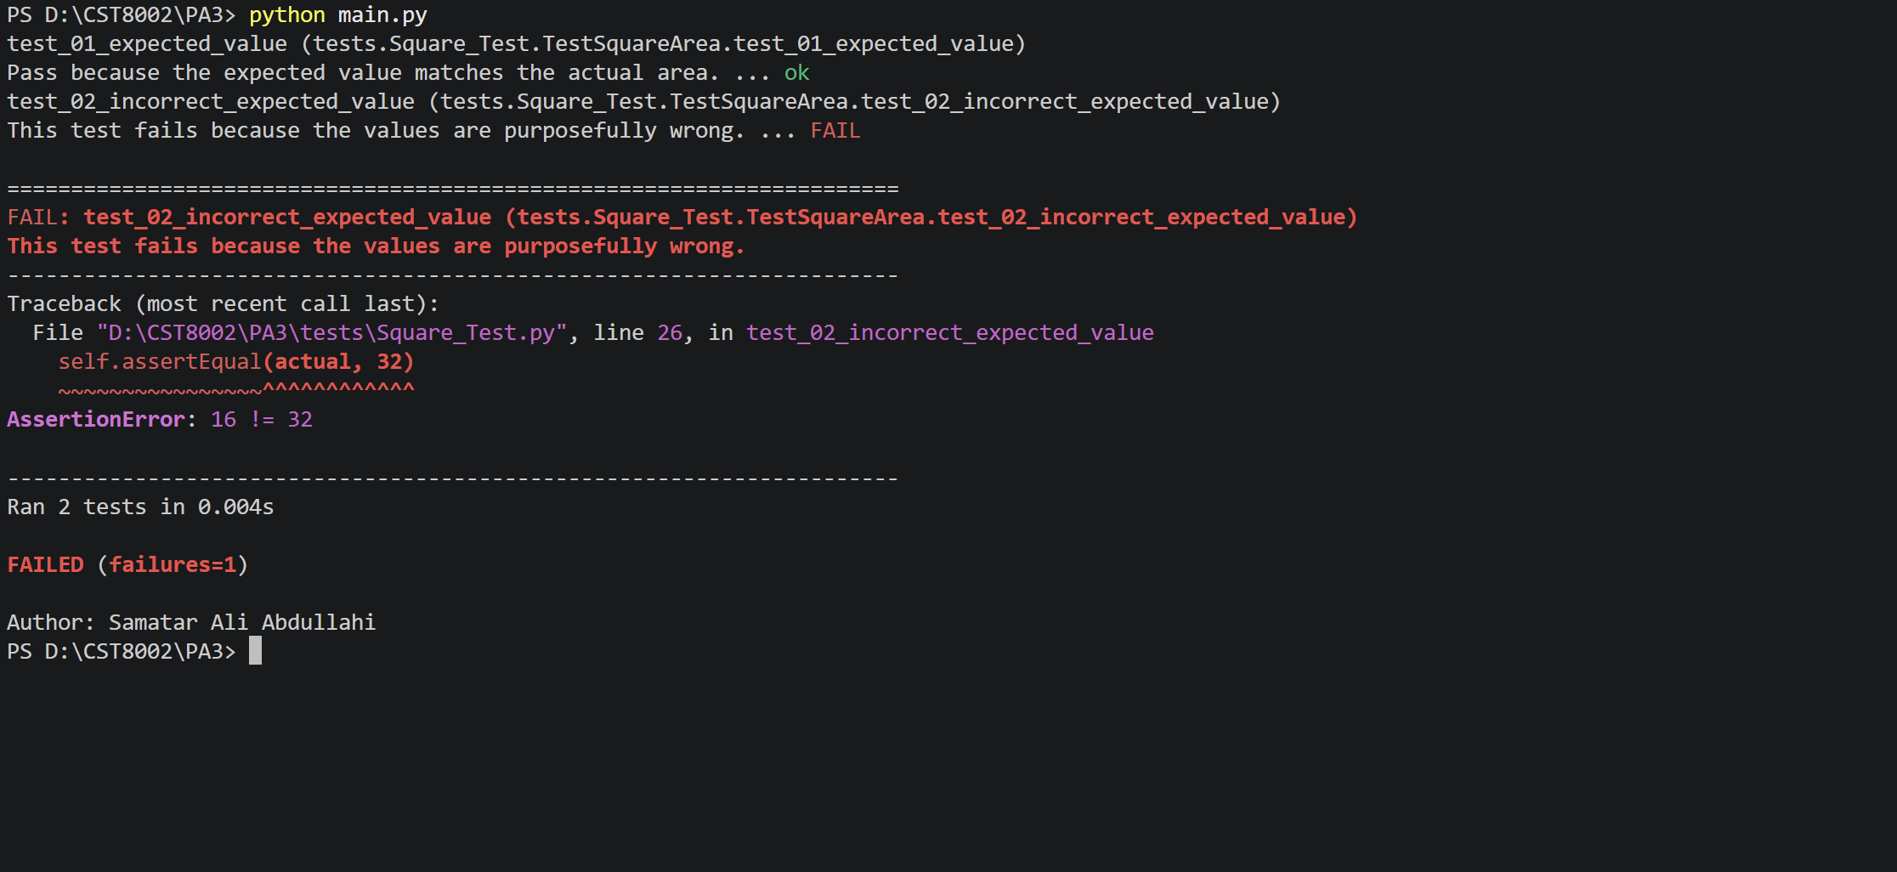
Figure 1. Running program with both test cases using 6 and 4 as values

Create Report (Microsoft Word Required)
- Cover page with your full name within it, the content of your report should start on page 2.
- Heading with name “Research”
  - Include the source(s) of your research using IEEE reference style.
- Heading with name “Program Demonstration via Screen Shots”
  - Include your screen shot(s) of the running unit test program, with requested outputs.
  - Add figure-text below the screen shot(s) as requested.

Submission
- Upload your MS Word document by the due date to Brightspace
- Upload a zip file of your programs source code by the due date to Brightspace
- You are not required to use version control for this assessment; however, it is a recommended approach.

Grading (Total 15 Points)
Criteria | Poor / Missing (0) | Below Expectations (1) | Meets Expectations (2) | Exceeds Expectations (3)
Research | Poor / Missing | Reference(s) missing many parts expected for IEEE format, and or not all requested references are present. | Reference(s) not in correct IEEE format, however, has most of the parts expected, and/or missing one or two of the requested references. | Reference(s) are in correct IEEE format, have all parts, and all the requested references are present.
Screen Shots, Running Program | Poor / Missing | Many screen shots are missing, and/or screen shots have no figure-text, and/or screen shots do not show student name. | At most one of the requested screen shots is missing, and/or most screen shots have figure-text without sentence(s), and/or some screen shots do not show student name. | All requested screen shots are present, and all screen shots have figure-text with full sentence(s), and all screen shots show student name.
Program Functionality | Poor / Missing | Program does not run correctly, e.g., crashes on start-up. | Program runs but does not have all functionality and or may have resource leaks and/or where applicable user interface may not be user friendly. | Program runs correctly to demonstrate requested features, has no resource leaks, and where applicable the user interface is user-friendly.
Program Structure | Poor / Missing | Program may be modularized (or not) but is within one code file. (The one exception would be a simple program like ‘hello world’.) | Program was separated out into separate modules and files but are all contained within one directory or folder. | Program is separated into separate modules, as well as separate code files as packages (directories or folders) are used to organize the code files as well.
Source Code, programmer comments. | Poor / Missing | Comments are present, but author’s name and/or IEEE reference are missing at top of all code files. Many classes, constructors and / or methods not commented on. No documentation comments used. | Comments are present but missing either author name, and/or IEEE reference(s) at top of one or more source code files. Documentation comments are not used for each class, constructor and / or method. | Comments are present, both student name as author, and IEEE reference(s) are at the top of each source code file within a programmer comment. Documentation comments used for all classes, constructors and methods.

Recommended Resources / Sources Cited
University of York. (2025 Aug 20). IEEE referencing style. subjectguides.york.ac.uk [Online]. Available: https://subjectguides.york.ac.uk/referencing-style-guides/ieee [Accessed: August 20, 2025].
- Suggestion: Expand the Website examples section on the right-hand side of the page.

[1]
M. Grinberg, “How to Write Unit Tests in Python, Part 3: Web Applications,” blog.miguelgrinberg.com. https://blog.miguelgrinberg.com/post/how-to-write-unit-tests-in-python-part-3-web-applications (accessed Oct. 10, 2026).

[2]
“Unit testing in Python: Quick tutorial and 4 best practices,” Octopus.com, 2026. https://octopus.com/devops/unit-testing/unit-testing-in-python/ (accessed Oct. 10, 2026).

[3]
Cody Engel, “How To Write Unit Tests (The Right Way).” YouTube, Feb. 22, 2021. Accessed: Oct. 10, 2026. [Video]. Available: https://www.youtube.com/watch?v=aId-WLZnvkw

